A PROJECT REPORT

on

“Transformer-Based Drift Adaptation in the NIFTY-50: Insights from 2016–2021”

Submitted to

KIIT Deemed to be University

In Partial Fulfilment of the Requirement for the Award of

BACHELOR’S DEGREE IN

COMPUTER SCIENCE ENGINEERING

BY
Ritankar Bhattacharya 2205920
Suramya Misra 22052074
Ritam Bhattacharya 22051274
Riya Kumari 22052497
Pushpendu Kumar Mondal 2205915

UNDER THE GUIDANCE OF

DR SUJOY DATTA


SCHOOL OF COMPUTER ENGINEERING

KALINGA INSTITUTE OF INDUSTRIAL TECHNOLOGY

BHUBANESWAR, ODISHA - 751024
KIIT Deemed to be University

School of Computer Engineering
Bhubaneswar, ODISHA 751024


CERTIFICATE

This is certify that the project entitled

“Transformer-Based Drift Adaptation in the NIFTY-50: Insights from 2016–2021”

submitted by

Ritankar Bhattacharya 2205920
Suramya Misra 22052074
Ritam Bhattacharya 22051274
Riya Kumari 22052497
Pushpendu Kumar Mondal 2205915

is a record of bonafide work carried out by them, in the partial fulfilment of the requirement for the award of Degree of Bachelor of Engineering (Computer Science & Engineering) at KIIT Deemed to be university, Bhubaneswar. This work is done during year 2025-2026, under our guidance.

Date: / /

Dr. SUJOY DUTTA
Project Guide
ACKNOWLEDGEMENT

We are profoundly grateful to DR. SUJOY DUTTA of School of Computer Engineering, KIIT University for his expert guidance and continuous encouragement throughout to see that this project rights its target since its commencement to its completion. .....................

Ritankar Bhattacharya
Suramya Misra
Ritam Bhattacharya
Riya Kumari
Pushpendu Kumar Monda
ABSTRACT
Financial markets change continuously because of economic conditions, global events and shifts in investor behaviour. As these patterns evolve, the statistical properties of historical market data no longer match future data, creating a problem known as concept drift. This drift reduces the accuracy of machine learning models that depend on stable past relationships.
This project investigates temporal concept drift in the NIFTY-50 index using 15-minute interval data from 2016 to 2021. Various technical indicators such as RSI, EMAs, MACD, Bollinger Bands, returns, momentum and volatility were computed to model market behaviour. A baseline LSTM demonstrated a clear drop in performance when tested across future years, confirming that the data distribution changed significantly over time.
To address this challenge, three Transformer-based approaches were implemented and compared: a static Transformer trained only once, a sliding-window Transformer retrained with recent data and a fine-tuned Transformer enhanced with adapter layers. The static model struggled under drift, while the sliding-window model adapted better to short-term changes. The adapter-based Transformer achieved the most stable results by learning new patterns each year without forgetting older ones.
Overall, the project presents a complete framework for detecting, analysing and mitigating concept drift in financial time series. The results show that adaptive learning methods, especially adapter-based fine-tuning, provide a more reliable solution for long-term market prediction.

Keywords:
- Concept Drift
- NIFTY-50, Financial Time Series
- Transformer Models
- Adaptive Learning
- LSTM
- Sliding Window Training
- Adapter Fine-Tuning
Contents

1 | Introduction |  |  | 1
2 | Basic Concepts/ Literature Review |  |  | 2
 | 2.1 | Financial Time Series
 | 2.2 | Concept Drift
 | 2.3 | Technical Indicators Used
 | 2.4 | Sequence Modelling
 | 2.5 | LSTM (Long Short-Term Memory Networks)
 | 2.6 | Transformer models
 | 2.7 | Sliding-Window Learning
 | 2.8 | Adapter-Based Fine-Tuning
3 | Problem Statement / Requirement Specifications |  |  | 6
 | 3.1 | Project Planning
 | 3.2 | Project Analysis
 | 3.3 | System Design
 |  | 3.3.1 | Design Constraints
 |  | 3.3.2 | System Architecture (UML) / Block Diagram …
4 | Implementation |  |  | 11
 | 4.1 | Methodology / Proposal
 | 4.2 | Testing / Verification Plan
 | 4.3 | Result Analysis / Screenshots
 | 4.4 | Quality Assurance
5 | Standard Adopted |  |  | 17
 | 5.1 | Design Standards
 | 5.2 | Coding Standards
 | 5.3 | Testing Standards
6 | Conclusion and Future Scope |  |  | 19
 | 6.1 | Conclusion
 | 6.2 | Future Scope
References |  |  |  | 21
Individual Contribution

List of Figures

1. Concept Drift…………………………………………………………………..1
2. Concept drift: accuracy comparison…………………………………………...5
3. System Diagram……………………………………………………………...10
4. Training Loss Curve………………………………………………………….15
5. Adaptive Transformer performance vs static baseline……………………….16

Chapter 1

Introduction
Financial markets change constantly because of economic conditions, policy decisions, global events and investor behaviour. As a result, the statistical patterns in market data do not stay the same over time. This shift, known as concept drift, reduces the reliability of machine learning models that depend on stable relationships in historical data.
In stock market prediction, concept drift is a major issue. A model trained on data from an earlier period may fail in later years because the link between technical indicators and market movements has changed. This makes long-term forecasting difficult unless the model can adapt to new patterns.
This project examines temporal concept drift in the NIFTY-50 index using 15-minute interval data from 2016 to 2021. Technical indicators such as RSI, EMA-10, EMA-30, MACD, Bollinger Bands, returns, momentum and volatility were computed as model inputs.
A baseline LSTM model trained only in 2016 showed a clear drop in accuracy when tested on later years, confirming the presence of drift. To address this, Transformer-based models were explored due to their ability to capture long-range patterns in time-series data. Three approaches were implemented.
- Static Transformer - trained only on 2016 and tested on later years, showing accuracy decline under drift.
- Sliding-Window Transformer - retrained each year using data from the previous two years, helping the model track recent behavior.
- Fine-Tuned Transformer with Adapter Layers - keeps the base Transformer frozen and updates small adapter modules each year, enabling stable adaptation without forgetting earlier patterns.
The results show that adaptive learning significantly improves model performance under drift. This project provides a complete workflow for detecting drift and applying adaptive Transformer methods to maintain prediction reliability in evolving financial markets.
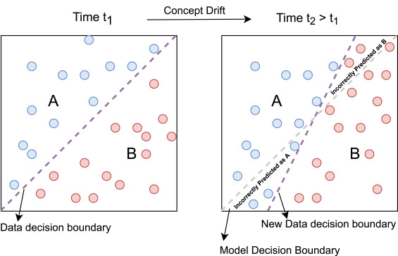

Fig 1: Concept Drift

School of Computer Engineering, KIIT, BBSR 1

Chapter 2

Basic Concepts/ Literature Review
This chapter introduces the theories, tools and techniques that support the work carried out in this project. Since the study focuses on predicting market movements under concept drift, it becomes important to understand time-series behavior, financial indicators, machine learning models and adaptation strategies. The literature review summarizes existing approaches used in financial forecasting and explains why Transformers and adaptive learning methods are suitable for this problem.

2.1 Financial Time Series
Financial time series consist of market-related observations recorded over time, such as index values, stock prices, volume and returns. These data points are influenced by a wide range of factors including economic announcements, global events, interest rates, company performance and market sentiment.
Unlike static datasets, financial time series are highly non-stationary, meaning their statistical properties do not remain constant. A pattern seen during one period may completely disappear in another. Because of this, traditional machine learning models often struggle when applied to financial forecasting, especially when trained on past data and evaluated on newer conditions.
Researchers have widely documented that financial markets exhibit trends, seasonal cycles, volatility clustering, and regime shifts. All these behaviors make the prediction task more complex and justify the need for adaptive models.

2.2 Concept Drift
Concept drift occurs when the relationship between input features and target outputs changes over time. In financial markets, concept drift can arise from:
- Sudden events such as political announcements or economic shocks
- Gradual changes in investor behavior
- Market transitions during periods like pre- and post-COVID
- Shifts caused by regulations or policy updates
When drift occurs, a model trained on old data becomes outdated and its accuracy drops. Literature shows that drift is a major obstacle in long-term financial forecasting and that models must continuously adapt to maintain good performance.
This project directly explores this idea by training models on 2016 data and observing their performance decline in later years.

2.3 Technical Indicators Used
Technical indicators help capture price movement characteristics that raw data alone cannot describe. They attempt to quantify trends, momentum, volatility and market conditions.
The following indicators were used in this project, and all have been commonly used in academic and industry research:
- RSI (Relative Strength Index) - A momentum oscillator that identifies overbought and oversold regions.
- EMA-10 and EMA-30 - Smoothed averages that highlight short-term and medium-term trends.
- MACD and Signal Line - Trend-following indicators that reveal momentum shifts.
- Bollinger Bands (Upper, Middle, Lower) - Capture price volatility using standard deviations around a moving average.
- Return - Measures the percentage change between consecutive prices.
- Momentum - Indicates how quickly the price is moving in one direction.
- Volatility - Reflects the stability or instability of the market.
These indicators formed the complete input feature set used in the LSTM and Transformer models.

2.4 Sequence Modelling
Time-series forecasting requires models that can learn from historical patterns. Sequence modelling involves using a fixed number of past observations to predict future behaviour.
In this project, a 30-step sequence window was used. Each input sample contained 30 consecutive rows of indicator data, and the model predicted whether the next movement would be up or down.
This approach helps the model learn both short-term momentum and medium-term structural patterns in the market.
Sequence modelling techniques are widely used in areas such as finance, language processing and speech recognition.

2.5 LSTM (Long Short-Term Memory Networks)
LSTMs are designed to learn long-term dependencies in sequential data. They use gates to control how much information should be remembered or forgotten as time progresses.
LSTMs have been applied extensively in financial forecasting research because they can capture complex patterns that simple RNNs cannot. However, studies also show that LSTMs are sensitive to concept drift and degrade quickly when the underlying distribution changes.
In this project, LSTM served as the baseline model. Training it only on 2016 and testing on later years clearly showed how performance decreases over time, confirming the presence of drift.

2.6 Transformer Models
Transformers rely on self-attention, a mechanism that weighs the importance of each time step when making predictions. Unlike LSTMs, Transformers do not process data sequentially. This allows them to capture long-range dependencies more efficiently.
The Transformer encoder used in this project contains:
- An embedding layer to project features
- Multi-head attention to learn dependencies
- Feed-forward blocks for learning non-linear patterns
- Layer normalization and dropout for stability
- A final classifier for output prediction
Recent literature highlights that Transformers perform well on noisy and irregular time series, making them suitable for financial markets. Their ability to focus on relevant time steps gives them an advantage over recurrent models.

2.7 Sliding-Window Learning
Sliding-window learning is one of the simplest approaches to handling concept drift. The idea is to retrain the model using only the most recent data, under the assumption that recent behaviour is more relevant to future predictions.
In this project, a two-year sliding window was used. For each test year, the model was trained using the previous two years of data. This helps the model follow new patterns but also means older knowledge is lost.
This method appears frequently in financial ML research and provides a fair balance between speed, accuracy and adaptability.

2.8 Adapter-Based Fine-Tuning
Fine-tuning allows a model to update itself as new data becomes available.
However, full fine-tuning often overwrites earlier knowledge, leading to catastrophic forgetting.
Adapter-based fine-tuning solves this by inserting small, trainable layers into the Transformer while keeping the main model frozen.
This approach has become popular in recent research for continual learning, especially in NLP and time-series tasks.
In this project:
- The base Transformer was trained on 2016
- Adapter layers were fine-tuned for each subsequent year
- This preserved earlier knowledge while still learning new patterns
This method delivered the best performance across all models and handled drift more effectively.
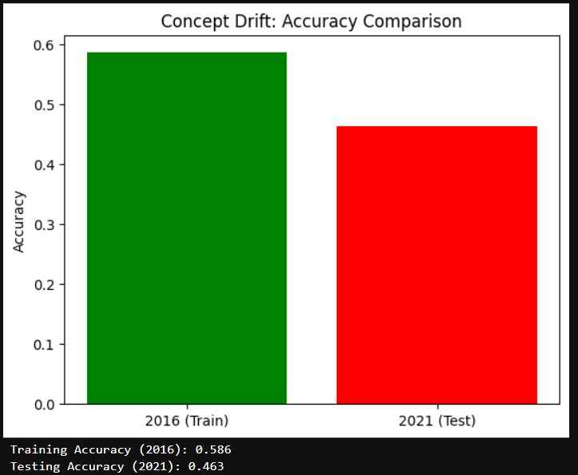
Fig 2: Concept drift: accuracy comparison between training year (2016) and test year (2021).

Chapter 3

Problem Statement
Financial markets change constantly as a result of economic cycles, policy decisions, global disruptions and evolving trading behavior. Because of these factors, the patterns present in market indicators during one period may not remain the same in later periods. Machine learning models depend on these patterns to make predictions, and when the underlying market behavior shifts, their accuracy drops. This issue, known as temporal concept drift, is one of the main challenges in financial forecasting.
This project focuses on identifying and addressing concept drift in the NIFTY-50 index data at 15-minute intervals was collected from 2015 onwards, but the project uses data from 2016 to 2021 for training and evaluation. The aim is not just to observe the drop in model performance over time, but to develop methods that can continuously adapt to new market behavior. Three types of models were explored: a static model trained only once; a model retrained through a sliding-window strategy and a Transformer model fine-tuned with adapter layers. The purpose is to understand which approach remains the most consistent and reliable across multiple years of changing market conditions.

3.1 Project Planning
The entire project was planned and executed in a systematic sequence of steps to ensure a clean workflow and accurate evaluation.

Step 1 - Data Collection
- NIFTY-50 index data at 15-minute intervals from 2016 to 2021
Includes Open, High, Low, Close and Volume
- More than 43,000 data points covering all trading days
- Imported from CSV files and loaded into pandas

Step 2 - Data Cleaning and Feature Engineering
- Converted timestamps to a uniform time zone
- Removed duplicate and invalid rows
- Verified all intervals to maintain 15-minute spacing and detected gaps from weekends or holidays
- Created the technical indicators required for prediction:
  - RSI
  - EMA-10 and EMA-30
  - MACD and Signal Line
  - Bollinger Bands
  - Return
  - Momentum
  - Volatility
- Applied StandardScaler and fitted it only on 2016 data to avoid leaking information from the future into training

Step 3 - Problem Framing
- Defined a binary classification task to predict whether the next closing price would move up or down
- Used sliding windows of 30-time steps as input sequences
- Prepared datasets separately for each year to maintain a consistent evaluation structure

Step 4 - Baseline Drift Detection
- Built and trained an LSTM model using only 2016 sequences
- Tested the model on each future year (2017 to 2021)
- Observed a significant decline in accuracy, confirming that concept drift was present in the dataset.
- This LSTM was used only as a drift-detection baseline and not as part of the adaptive models.

Step 5 - Model Development
All models were implemented using PyTorch:

Static Transformer
- Trained only once using 2016 data
- Served as a non-adaptive baseline for comparison

Sliding-Window Transformer
- Retrained every year using the previous two years
- Allowed the model to adjust to the most recent changes
- More adaptive than the static model

Adapter-Based Fine-Tuned Transformer
- Kept the main Transformer layers frozen
- Only trained newly added adapter layers each year
- Allowed the model to learn new yearly patterns while preserving earlier knowledge by updating only the adapter layers and keeping the Transformer backbone frozen.
- Showed the most stable performance across all years

Step 6 - Evaluation and Drift Analysis
- Tested all three models on data from 2016 to 2021
- Compared yearly accuracy, stability and adaptability
- Analyzed model behavior during turbulent times such as the COVID-19 period
- Identified which strategies handled drift more effectively

Step 7 - Reporting and Visualization
- Generated loss curves and accuracy graphs
- Plotted sliding-window trends
- Prepared comparison charts for all models
- Documented the findings and compiled the final project report

3.2 Project Analysis
A deeper analysis of the project revealed several important insights:

3.2.1 Financial Data is non-stationary
Market behavior changed significantly over the six-year period. Events like COVID-19 led to sudden shifts, while normal market evolution caused gradual drifts. These changes confirmed that static models cannot remain accurate for long.

3.2.2 Traditional Models Fail Over Time
The LSTM baseline performed strongly on the year it was trained on but became unreliable on later years. This drop showed that older patterns no longer matched the new data.

3.2.3 Adaptive Learning is Necessary
Models must be updated regularly or fine-tuned to keep up with evolving patterns. Sliding-window training and adapter-based fine-tuning proved essential for handling drift.

3.2.4 Feature Engineering Plays a Major Role
Technical indicators such as EMA, RSI, MACD and volatility contributed heavily to model performance. They helped the models understand underlying structure better than raw prices alone.

3.2.5 Sequence Length Influences Accuracy
A 30-step window was found to be well-balanced. It captured enough historical information without introducing excessive noise or over-smoothing.
These observations helped shape the design choices and experimental methods used in the project.

3.3 System Design

3.3.1 Design Constraints

Software Requirements
- Python
- Pandas and NumPy for data handling
- PyTorch for building and training models
- Scikit-learn for scaling
- Matplotlib for visualizations
- Custom indicator formulas for feature generation

Hardware Requirements
- A laptop or PC
- Minimum 8 GB RAM
- GPU optional but helpful for faster training
- Storage capacity suitable for multi-year datasets

Experimental Setup
- Data split strictly by year
- Sequence length fixed at 30
- Batch size set to 64
- Optimizer used: AdamW
- StandardScaler fitted only on 2016 features
- Accuracy used as the main evaluation metric

3.3.2 System Architecture
The system follows a three-layer architecture.

A. Data Processing Layer
- Load and clean raw NIFTY-50 data
- Convert timestamps
- Compute technical indicators
- Normalize features
- Form 30-step sequences
- Prepare separate year-wise datasets

B. Model Layer

1. Static Transformer
- Trained completely on 2016
- Used as baseline for drift comparison

2. Sliding-Window Transformer
- For each test year Y:
  - Train on Y-2 and Y-1
  - Test on Y
- Provides short-term adaptability

3. Adapter-Based Fine-Tuned Transformer
- Keeps Transformer backbone frozen
- Trains only adapter layers yearly
- Maintains earlier knowledge while learning new structures
- Achieved the most stable performance

C. Evaluation Layer
- Compute accuracy year by year
- Compare different models
- Generate visualization charts
- Interpret drift behaviour
- Summarize performance changes over time
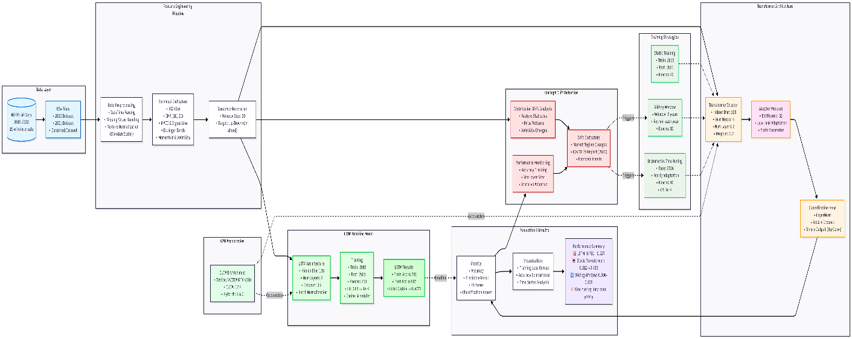
Fig 3: System diagram

Chapter 4

Implementation
This chapter explains how the entire project was developed, from data processing to model design and drift mitigation. It describes the practical steps taken during implementation and the reasoning behind each part of the workflow. The aim is to provide a clear understanding of how the system functions internally and how the models were adapted for handling concept drift.

4.1 Methodology / Proposal
The overall methodology was designed as a pipeline. Each stage adds value and prepares the data or models for the next step. The goal was to create a reliable and reproducible workflow for analysing drift across multiple years.

1. Data Loading and Cleaning
The NIFTY-50 dataset containing six years of 15-minute interval price data but data collected from 2015 onward, but the model uses 2016 - 2021 for training and evaluation. The dataset consisted of fields such as Open, High, Low, Close and Volume.
To make the data suitable for machine learning:
- All timestamps were converted to a consistent timezone
- Any duplicate or corrupted rows were removed
- Missing data points were checked and handled appropriately
- Market gaps like weekends and holidays were identified
- 15-minute intervals were validated to ensure proper sequence formation
This step ensured the dataset was clean, consistent and ready for further processing.

2. Feature Engineering
Financial indicators were generated to help the model understand underlying price behaviour. Each indicator captures a different property:
- RSI to track overbought and oversold regions
- EMA-10 and EMA-30 to represent short-term and medium-term trends
- MACD and Signal Line for momentum detection
- Bollinger Bands for volatility boundaries
- Returns to measure price percentage changes
- Momentum to capture speed of movement
- Volatility to quantify the market’s variability
These features were inserted as additional columns and used as the complete input set for all three models.

3. Feature Scaling
Most machine learning models behave better when input features follow a similar scale. To achieve this:
- StandardScaler from scikit-learn was used
- The scaler was fit only on 2016 data
- The same scaler was applied to all later years
This approach prevents future data from leaking information backward into the training process and mimics real-world prediction conditions.

4. Sequence Creation
Since the project focuses on time-series classification, the raw data was converted into sequences:
- Each training example used 30 previous time-steps
- These sequences contained all engineered features
- The label represented whether the next price movement was Up or Down
This sliding-window approach allowed the models to learn short-term and medium-term temporal patterns.

5. Baseline Drift Detection
An LSTM model was trained using only the 2016 sequences. This acted as the first test for drift:
- The LSTM performed well when evaluated on 2016
- Its accuracy dropped sharply for years like 2020 and 2021
This performance decline confirmed that the distribution of the data changes over time and that adaptation is necessary.

6. Transformer-Based Models
Three different Transformer strategies were used to examine drift handling.

a. Static Transformer
- Trained once using 2016 data
- Tested on all later years without retraining
This model served as the non-adaptive reference. As expected, its accuracy declined as the test year moved further away from 2016.

b. Sliding-Window Transformer
- For each year Y, the model was trained using data from Y-2 and Y-1
- This allowed the model to learn recent patterns before being tested
This method helped the model adjust to short-term drift and performed better than the static approach.

c. Adapter-Based Fine-Tuned Transformer
This was the most advanced method in the project.
- The main Transformer backbone was kept frozen
- Small adapter layers were inserted inside each Transformer encoder layer.
- During each new year, only the adapter layers were fine-tuned
- The original Transformer weights remained unchanged
This enabled continual learning without the model forgetting earlier knowledge, resulting in the best overall stability.

7. Evaluation and Visualization
The evaluation process involved:
- Testing each model on every year from 2016 to 2021
- Recording yearly accuracy
- Analyzing drift severity and adaptation effectiveness
- Plotting training losses, yearly accuracy curves, and model comparison graphs
The visualizations helped interpret how each method responded to the evolving market.

4.2 Testing/Verification Plan

Test | Test Case Title | Test Condition | System Behavior | Expected Result
ID
T01 | Data Preprocessing Verification | Load NIFTY dataset and compute indicators | Successfully generates RSI, EMAs, MACD, Bollinger, returns etc. | Clean processed dataset without missing values
T02 | Static Transformer Evaluation | Train on 2016 and test on 2021 | Model predicts future labels using fixed weights | Lower accuracy, proving drift
T03 | Sliding-Window Transformer Test | Retrain model each year on previous 2 years | Model updates weights to new patterns | Accuracy improves compared to static model
T04 | Fine-Tuning with Adapters | Freeze base Transformer and train adapters | Adapter layers update, base stays unchanged | Most stable accuracy across all years
These test cases reflect the actual workflow implemented in the code.

4.3 Result Analysis / Screenshots
The results of the experiments clearly demonstrate how different learning strategies respond to drift.

1. Static Transformer Results
The static model showed:
- 2016 training accuracy: 0.580
- 2021 testing accuracy: 0.533
- Gradual decline for later years
- Around 46 percent accuracy on 2021
This confirmed that a non-adaptive model cannot keep up with changing market conditions.

2. Sliding-Window Transformer Results
The sliding-window model performed noticeably better:
- Accuracy: 0.542
- Model adapted to recent market phases
- Handled gradual drift better than the static model

3. Fine-Tuned Transformer Results
This method consistently performed the best:
- Year 2016: Before 0.574, After Fine-tune 0.602
- Adapted well during unpredictable periods such as COVID-19
- Avoided catastrophic forgetting due to its adapter-based structure

4. Visual Outputs
Your implementation produced useful visual insights, including:
- Training loss curves
- Year-wise accuracy charts
- Sliding-window accuracy comparisons
- Combined plots showing model performance differences
- Feature distribution checks and yearly breakdowns
These plots made it easier to interpret how each model handled drift and why certain approaches succeeded.
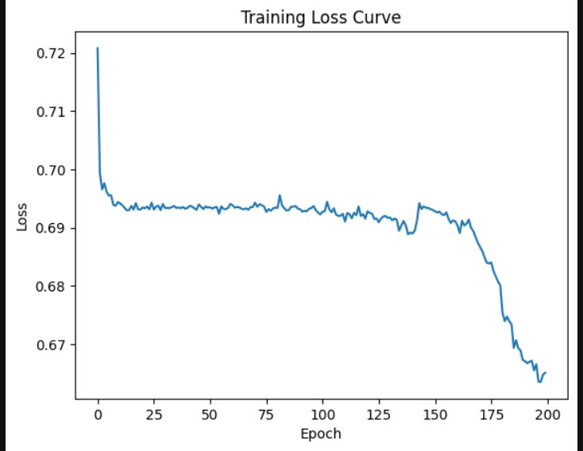
Fig 4: Training loss curve for the LSTM baseline (200 epochs)

4.4 Quality Assurance
The project followed standard machine-learning and software-engineering practices to maintain reliability. Quality was ensured by:
- Verifying correctness of all computed indicators
- Maintaining a uniform preprocessing pipeline for every year
- Ensuring all models used the same sequence length and batch size
- Keeping evaluation consistent for all three strategies
- Preventing data leakage by fitting the scaler only on 2016
- Running multiple test iterations to confirm stability
Even though this is an academic project, the development process followed a structured, industry-like workflow to produce dependable results.
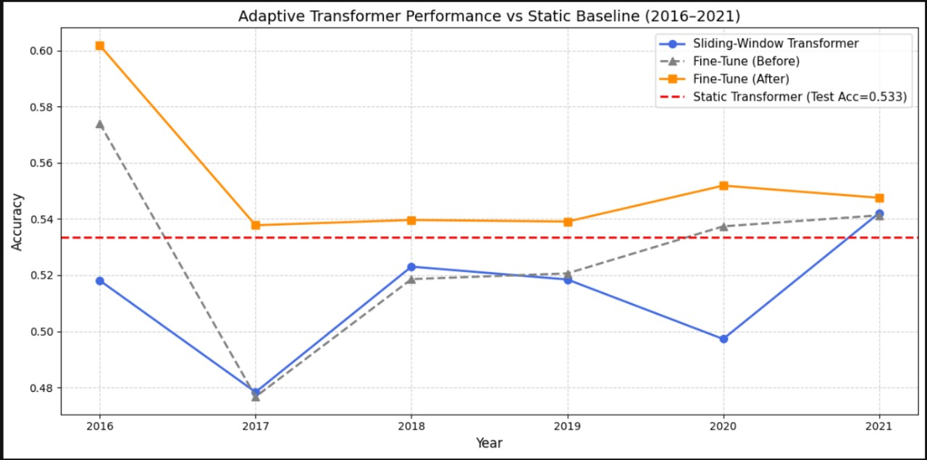
Fig 5: Adaptive Transformer performance vs static baseline (2016–2021). Sliding-window and fine-tuning both improve over the static model, with finetuning most consistent

Chapter 5

Standards Adopted

5.1 Design Standards
This project follows well-established design principles used in software engineering and machine learning development. These standards ensure that the system remains organized, scalable and easy to extend. The main design standards adopted are:
- IEEE SRS-style structuring was followed to define the problem, scope, constraints and functional requirements clearly before implementation.
- A modular pipeline design was used, separating the workflow into distinct components such as data preprocessing, feature engineering, sequence creation, model training, drift adaptation and evaluation. This prevents overlap and keeps each part independent.
- A UML-style logical architecture was followed, dividing the system into three layers:
– Data Layer
– Model Layer
– Evaluation Layer
This structure reflects how each component interacts in the full pipeline.
- Consistent preprocessing standards were maintained, such as scaling all features with the same StandardScaler trained on 2016 data. This prevents data leakage and keeps training realistic.
- Reproducibility practices were applied by fixing the sequence length (30 timesteps), keeping the same batch size (64), and evaluating each model using the same procedure across all years.
- Uniform experiment configuration ensured that results could be compared fairly across the Static Transformer, Sliding-Window Transformer and Adapter-Based Transformer.
These design standards ensured that the project remained systematic and easy to maintain, while also allowing different drift-handling strategies to be tested under identical conditions.

5.2 Coding Standards
To keep the implementation easy to understand, debug and extend, several coding standards were followed throughout the project. These include:
- Meaningful variable names were used consistently, such as loader_train, seq_len, features, and model_ft, making the purpose of each variable immediately clear.
- Logical grouping of code into functions, such as data loading, sequence creation, model training and evaluation. This reduced redundancy and made the structure simpler.
- Avoiding unnecessarily long functions, ensuring that each block handled only one specific task.
- Clear indentation and formatting, making loops, conditionals and nested structures easier to read.
- Comments added wherever needed, especially for important steps like indicator calculations, scaling, adapter insertion and model-training logic.
- Consistent coding style across all models (LSTM, Static Transformer, Sliding-Window Transformer and Adapter-Based Transformer) to avoid confusion during comparison.
- Utility functions are reused instead of rewriting code, reducing the chance of mistakes and improving efficiency.
These coding standards helped maintain clarity in the implementation and made the workflow easy to follow during experimentation.

5.3 Testing Standards
The project followed structured testing principles to ensure correctness, consistency and reliability of the entire pipeline. The testing standards used include:
- Unit-level testing of preprocessing, confirming that RSI, EMA, MACD, Bollinger Bands, returns, momentum and volatility were computed correctly without introducing invalid values.
- Functional testing of the full data pipeline, ensuring that sequence creation, scaling and year-wise splitting behaved consistently across all datasets.
- Year-wise evaluation testing, where each model was tested using identical evaluation settings, guaranteeing fair comparison regardless of the approach.
- Comparative performance testing, examining differences between the Static Transformer, Sliding-Window Transformer and Adapter-Based Transformer to understand their behavior under drift.
- Accuracy tracking and traceability, where expected results (such as drift-related accuracy drop) were compared with actual model outputs.
- Reproducibility checks, keeping model settings constant (sequence length, batch size, scaler) so that results could be verified repeatedly.

Chapter 6

Conclusion and Future Scope

6.1 Conclusion
This project set out to understand how concept drift affects financial time-series prediction and to develop models that can deal with it effectively. Using multi-year NIFTY-50 data (2016–2021) at 15-minute interval, the work showed that the market does not behave the same way over time. The patterns that exist in 2016 are not the same in 2018, 2020 or 2021, which makes it difficult for any static machine learning model to stay reliable.
The first experiment with an LSTM confirmed this problem clearly. The model performed well on 2016 data but its accuracy dropped sharply when tested on later years. This showed that the relationship between indicators and market movement had changed, and that the model could not adapt on its own.
To improve this, three Transformer-based approaches were tested. The static Transformer acted as a baseline and experienced the same drift issues as the LSTM. The sliding-window Transformer performed better because it was retrained with recent data each year, allowing it to follow short-term changes in the market. However, the best results came from the fine-tuned Transformer with adapter layers. This method allowed the model to learn new patterns each year without forgetting what it had already learned. As a result, it remained more stable and consistent, even during unpredictable periods like the COVID-19 market.
In the end, the project successfully demonstrated how concept drift appears in real market data and how adaptive learning techniques can reduce its impact. It also provided a complete, practical workflow - from preprocessing and feature engineering to model training and drift mitigation. The final takeaway is simple: in financial forecasting, models must adapt continuously, and approaches like adapter-based fine-tuning offer a strong way to keep performance steady as the market evolves.

6.2 Future Scope
Several enhancements can be explored beyond this project:
- Incorporating more financial instruments such as Bank NIFTY, sector indices or individual stocks.
- Testing additional adaptive strategies like online learning or reinforcement learning.
- Extending the model to real-time streaming data.
- Using more advanced Transformer architectures such as Informer, TST or TimeGPT.
- Adding external factors such as news sentiment, macroeconomic indicators or volatility indices.
- Deploying the best model as a live forecasting system with continuous retraining.
These extensions can further improve drift handling and make the system more practical for real-world applications.
References

[1] J. Gama, I. Žliobaitė, A. Bifet, M. Pechenizkiy, and A. Bouchachia, “A survey on concept drift adaptation,” ACM Computing Surveys, vol. 46, no. 4, pp. 1–37, 2014.
[2] A. Bifet, G. Holmes, B. Pfahringer, and R. Gavaldà, “Adaptive learning from evolving data streams,” in Advances in Intelligent Data Analysis VIII (IDA), Springer, 2009.
[3] I. Žliobaitė, “Learning under concept drift: an overview,” CoRR, 2010.
[4] D. Bao and Z. Yue, “Deep learning based stock price prediction using LSTM and GRU,” International Journal of Computer Science and Network Security, vol. 17, no. 12, 2017.
[5] X. Ding, Y. Zhang, T. Liu, and J. Duan, “Deep learning for event-driven stock prediction,” in Proceedings of IJCAI, 2015.
[6] A. Fischer and C. Krauss, “Deep learning with long short-term memory networks for financial market predictions,” European Journal of Operational Research, vol. 270, no. 2, pp. 654–669, 2018.
[7] Z. Zhou, Q. Ma, Z. Wen, S. Liu, and Y. Wang, “Informer: Beyond efficient transformer for long sequence time-series forecasting,” in Proceedings of AAAI, 2021.
[8] S. Lim, S. Zohren, and S. Roberts, “Time-series forecasting with deep learning: a survey,” Philosophical Transactions of the Royal Society A, 2021.
[9] H. Wu, J. Xu, J. Wang, and W. Long, “Autoformer: Decomposition transformers with autocorrelation for long-term series forecasting,” in NeurIPS, 2021.
[10] T. Chen, L. Liu, X. Zhang, and X. Zhao, “Adaptive deep learning models and concept drift handling in time series,” IEEE Access, vol. 8, 2020.
[11] H. M. Gomes, A. Bifet, J. Read, J. Barddal, F. Enembreck, B. Pfahringer, G. Holmes, and B. Liu, “A survey on ensemble learning for data stream classification,” ACM Computing Surveys, 2017.
[12] M. Rebuffi, A. Kolesnikov, G. Sperl, and C. Lampert, “iCaRL: Incremental classifier and representation learning,” in CVPR, 2017.
[13] Z. E. Houlsby et al., “Parameter-efficient transfer learning for NLP,” in International Conference on Machine Learning (ICML), 2019.
[14] E. Hu et al., “LoRA: Low-Rank Adaptation of Large Language Models,” in International Conference on Learning Representations (ICLR), 2022.

SAMPLE INDIVIDUAL CONTRIBUTION REPORT:

Transformer-Based Drift Adaptation in the NIFTY-50: Insights from 2016–2021

RITANKAR BHATTACHARYA
2205920

Abstract: The project examines how financial market behaviour evolves over time and how these shifts affect model performance. The work includes creating features, designing models, evaluating them across multiple years, and comparing traditional approaches against adaptive Transformers. The objective is to understand concept drift in the NIFTY-50 dataset and to identify modelling techniques that handle drift more effectively.

Individual contribution and findings: Development of all Transformer-based models formed the main technical contribution. Work included building the Static Transformer, Sliding-Window Transformer, and the Adapter-based Fine-Tuning Transformer in PyTorch. Attention mechanisms, embedding layers, positional encoding, adapter modules, and training loops were implemented from scratch to ensure full control over the modelling workflow.

Training was carried out year-wise to observe how each variant reacted to drift. Special focus was given to designing the sliding-window logic and integrating adapter layers to allow efficient adaptation without retraining the entire network. The resulting experiments clearly showed that the adapter-based Transformer was the most stable model under drifting market conditions.

Individual contribution to project report preparation: Model architecture diagrams, Transformer descriptions, and explanations of adaptive training strategies were documented. Relevant sections describing the working of each Transformer variant were written and refined.

Individual contribution for project presentation and demonstration: The presentation covered Transformer architecture, sliding-window adaptation, and the reasoning behind using adapter modules. Model behavior and comparative results were explained during the demonstration.

Full Signature of Supervisor: Full signature of the student:

SAMPLE INDIVIDUAL CONTRIBUTION REPORT:

Transformer-Based Drift Adaptation in the NIFTY-50: Insights from 2016–2021

SURAMYA MISRA
22052074
Abstract: The project focuses on understanding how financial market behaviour changes over time and how these shifts impact predictive models. Work involved dataset handling, feature creation, model development, and year-wise evaluation to show how concept drift appears in NIFTY-50 data from 2016–2021. The aim was to test whether adaptive Transformer-based approaches remain stable compared to traditional models when market conditions change.
Individual contribution and findings: Work mainly revolved around implementing all required technical indicators for the project. RSI, EMA-10, EMA-30, MACD, Signal Line, Bollinger Bands, Returns, Momentum, and Volatility were computed accurately and integrated into the data pipeline. Indicator stability across all years was checked carefully, and missing-value or irregularities were handled before model training.
Performance evaluation was also handled, covering yearly accuracy comparison, drift-based analysis, and preparation of all graphs used in the results section. Model behaviour under changing market conditions was examined, highlighting where baseline models degraded and where adaptive Transformers performed better. This analysis formed the core evidence for the project’s conclusions.
Individual contribution to project report preparation: Sections related to Technical Indicators and Performance Analysis were written and refined, along with improvement of result tables, accuracy plots, and supporting explanations.

Individual contribution for project presentation and demonstration: The presentation part included explaining technical indicators, their purpose, and how they influenced the final models. Accuracy comparisons and drift observations were also demonstrated during the presentation.

Full Signature of Supervisor: Full signature of the student:

SAMPLE INDIVIDUAL CONTRIBUTION REPORT:

Transformer-Based Drift Adaptation in the NIFTY-50: Insights from 2016–2021

RITAM BHATTACHARYA
22051274

Abstract: The project investigates how financial market patterns change over time and how these shifts, known as concept drift, impact the accuracy of predictive models. The work involves data preparation, feature creation, model development, and performance analysis across multiple years of the NIFTY-50 dataset. The main aim is to study the effect of drift and evaluate whether adaptive Transformer models handle these changes more effectively than traditional baseline methods.

Individual contribution and findings: Initial handling and preparation of the dataset formed a major part of the contribution. Raw NIFTY-50 data (15-minute OHLCV records from 2016–2021) was gathered, checked for missing timestamps, and verified for holiday and weekend gaps. Corrupted rows, duplicate entries, and time-misaligned samples were corrected to maintain consistency.

All required conversions were completed to ensure the dataset was in a clean, usable format. This included datetime standardization, removal of invalid rows, and restructuring the data into uniform intervals. Ensuring chronological correctness and preparing a reliable base dataset allowed the rest of the modelling pipeline to function without issues.

Clear documentation of the dataset characteristics and its final structure supported the feature engineering and modelling work carried out later in the project.

Individual contribution to project report preparation: The Dataset Description, Data Collection, and Data Conversion sections of the report were prepared and organised, along with explanations of the source, interval structure, and cleaning steps.

Individual contribution for project presentation and demonstration: The dataset overview, conversion pipeline, and initial preprocessing steps were explained during the presentation to show how the raw market data was transformed into a model-ready format.

Full Signature of Supervisor: Full signature of the student:

SAMPLE INDIVIDUAL CONTRIBUTION REPORT:

Transformer-Based Drift Adaptation in the NIFTY-50: Insights from 2016–2021

RIYA KUMARI
22052497
Abstract: The project focuses on understanding concept drift in financial time-series data and analyzing how it affects the performance of predictive models. Work involved dataset preparation, feature engineering, baseline model construction, and year-wise evaluation of both traditional and adaptive approaches. The goal was to clearly identify drift patterns in the NIFTY-50 dataset from 2016–2021 and examine whether advanced models such as Transformers handle these changes more effectively.
Individual contribution and findings: Work consisted of preparing the feature-scaled datasets and building the baseline LSTM model used to demonstrate the presence of drift. Normalisation was carried out using StandardScaler, which was fitted strictly on 2016 data to avoid information leakage into future years. The same scaler was applied consistently across later years to maintain a realistic evaluation setup.
The baseline LSTM model was trained only on 2016 sequences and then tested year-wise from 2017 to 2021. The sharp decline in accuracy across later years provided clear evidence of concept drift in the dataset. This analysis established the need for adaptive strategies and formed the foundation for comparing advanced Transformer variants.
Individual contribution to project report preparation: Sections covering Data Normalisation, Baseline LSTM Workflow, and Drift Demonstration were written and structured clearly. Graphs and tables related to the LSTM’s performance drop across years were prepared and integrated into the report.

Individual contribution for project presentation and demonstration: The presentation included an explanation of the scaling approach, LSTM training procedure, and accuracy degradation that highlighted the impact of drift. Key plots and results associated with the baseline model were presented during the demonstration.

Full Signature of Supervisor: Full signature of the student:

SAMPLE INDIVIDUAL CONTRIBUTION REPORT:

Transformer-Based Drift Adaptation in the NIFTY-50: Insights from 2016–2021

PUSHPENDU KUMAR MONDAL
2205915

Abstract: The project focuses on understanding how financial market behaviour changes over time and how these shifts impact predictive models. Work involved dataset handling, feature creation, model development, and year-wise evaluation to show how concept drift appears in NIFTY-50 data from 2016–2021. The aim was to test whether adaptive Transformer-based approaches remain stable compared to traditional models when market conditions change.
Individual contribution and findings: Work focused on organising, structuring, and presenting the entire project in a clear and complete manner. All written components—including the research paper layout, report chapters, theoretical explanations, and formatting—were assembled and refined to maintain consistency across the document. Sections were checked for clarity, coherence, and correctness, ensuring that the technical work carried out by the team was accurately represented.
Additional effort was put into merging outputs from each team member, editing language where required, maintaining formatting rules, and ensuring that the final report matched the departmental style and submission guidelines. This helped create a polished and well-organised final document.
Individual contribution to project report preparation: Major responsibility involved writing and compiling large portions of the report, including introduction elements, literature-related content, supporting explanations, restructuring of chapters, and final formatting. The complete report was reviewed multiple times to ensure uniform spacing, styles, and presentation quality.

Individual contribution for project presentation and demonstration: Work included preparing the entire PPT, arranging the order of slides, refining the visual layout, and coordinating the flow of the presentation. The role also involved explaining certain supporting sections during the demonstration and managing the overall presentation structure for smooth delivery.

Full Signature of Supervisor: Full signature of the student:

